Nama : Farkhan Mauriza

NIM : 18090103

Kelas : 5D

Laporan Praktikum 4

1. Source Code

Web.php -> application/controllers/

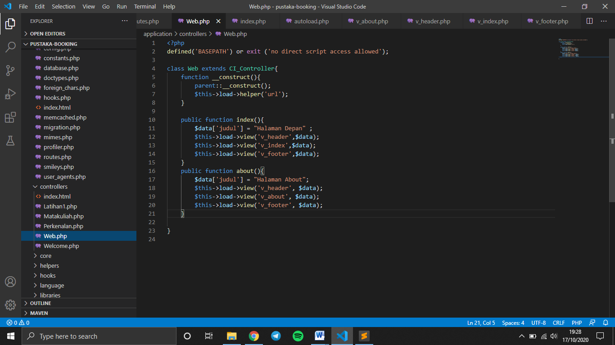

v_header.php -> application/views/

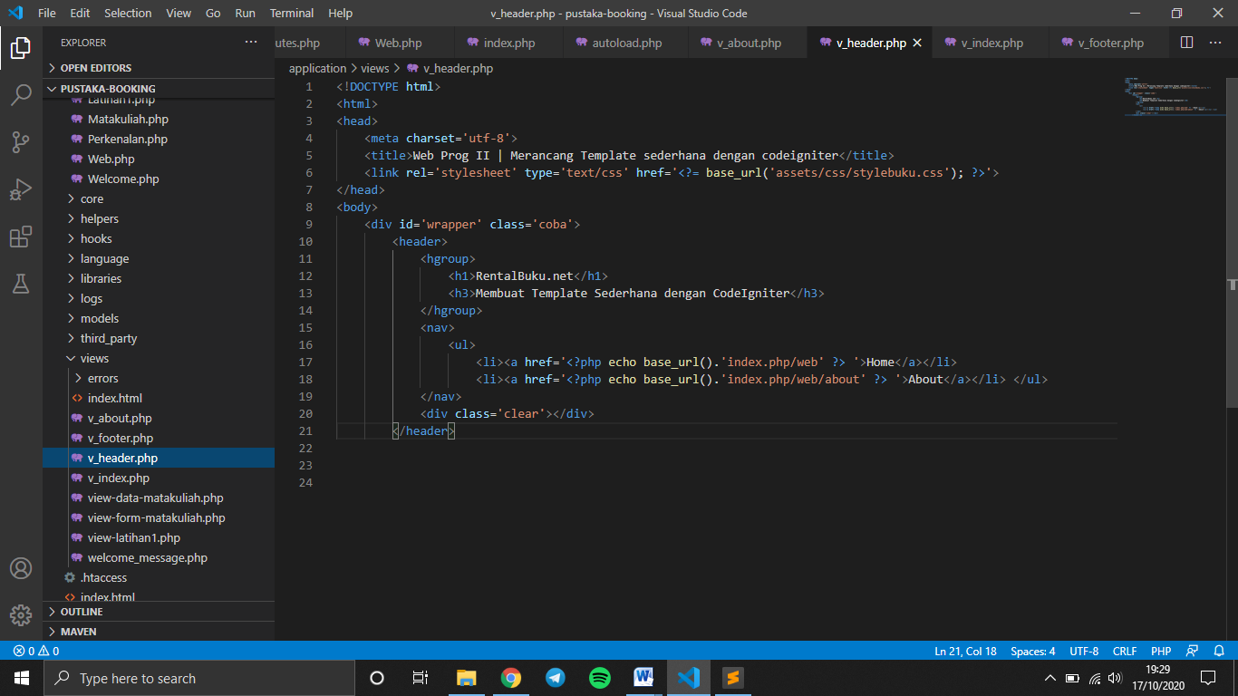

v_index.php -> application/views/

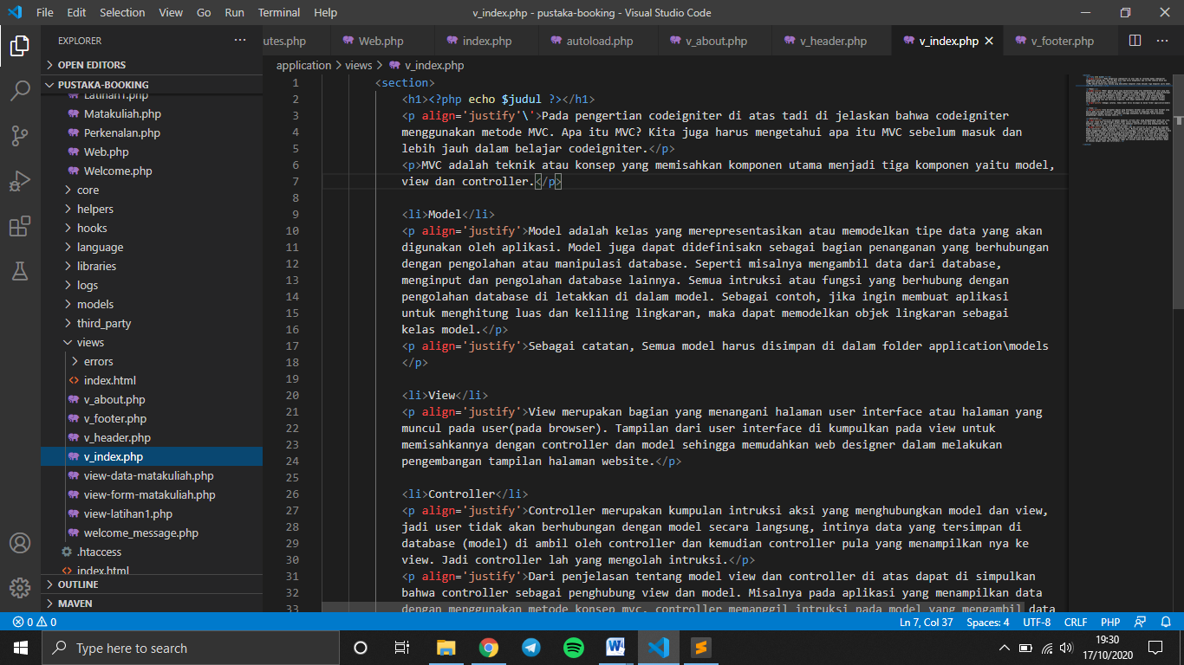

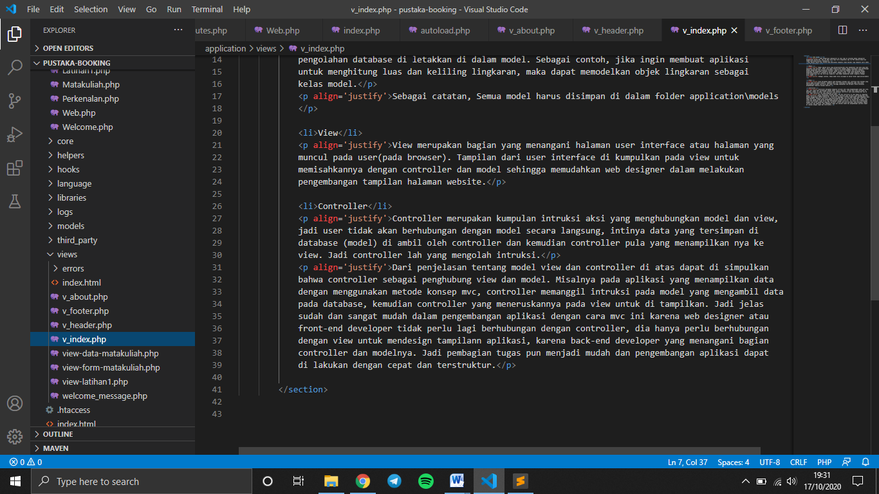

v_footer ->application/views/

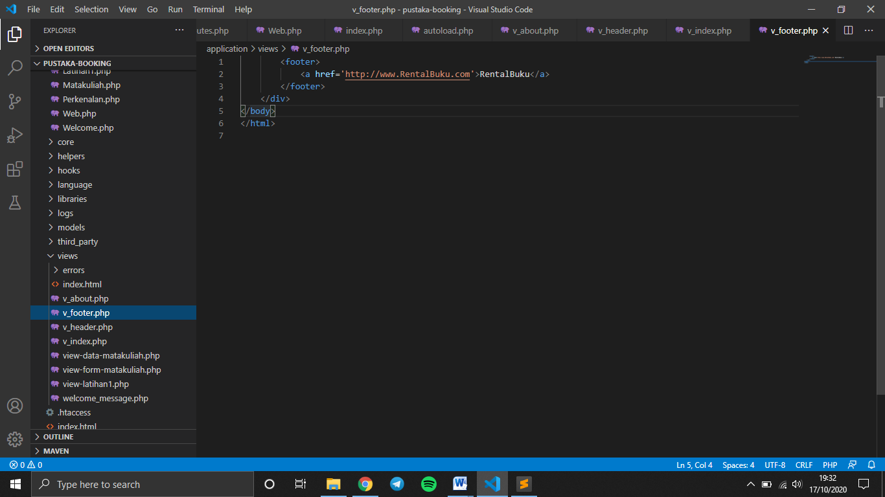

stylebuku.css -> pustaka-booking/assets/css/

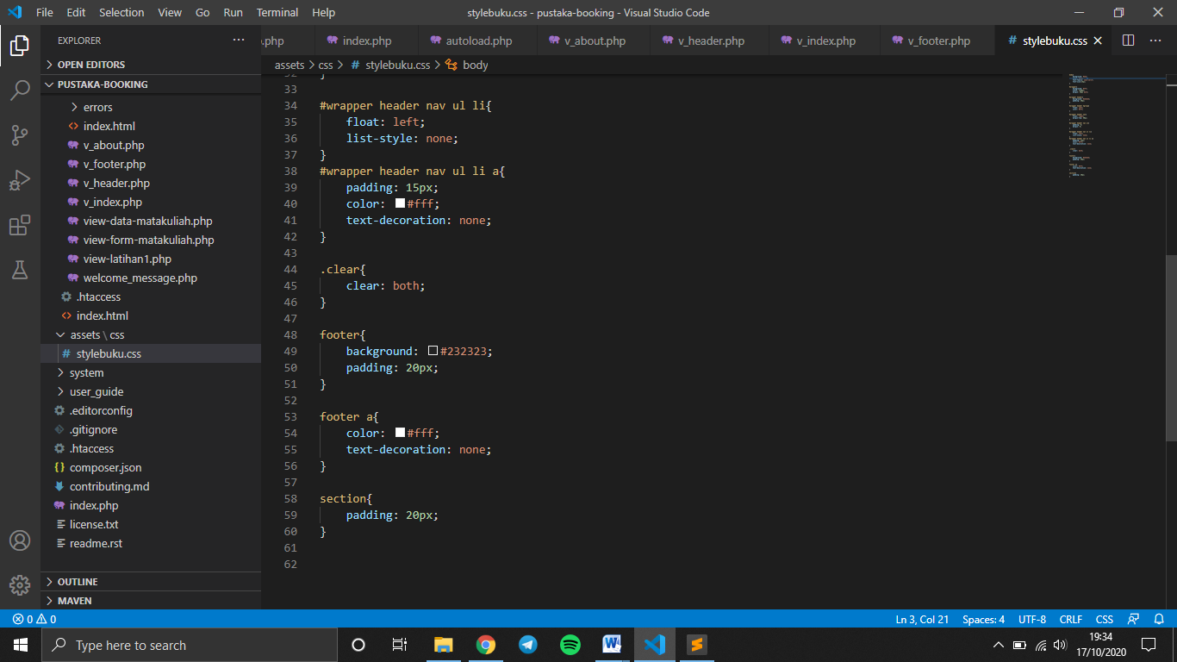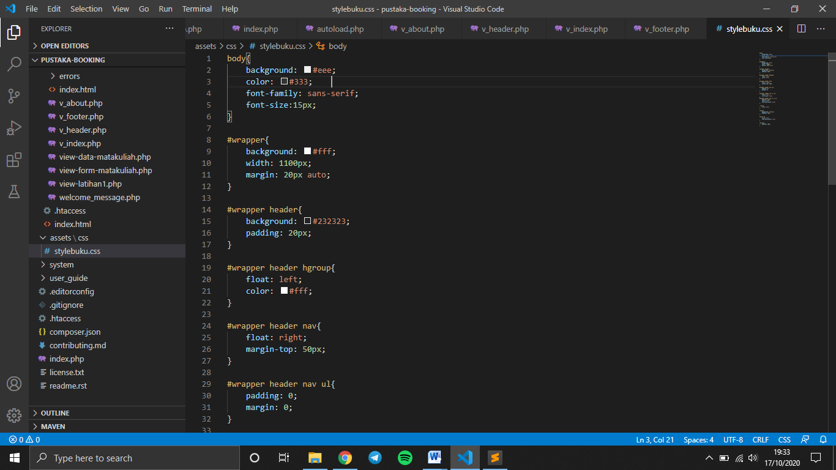

config.php -> application/config/

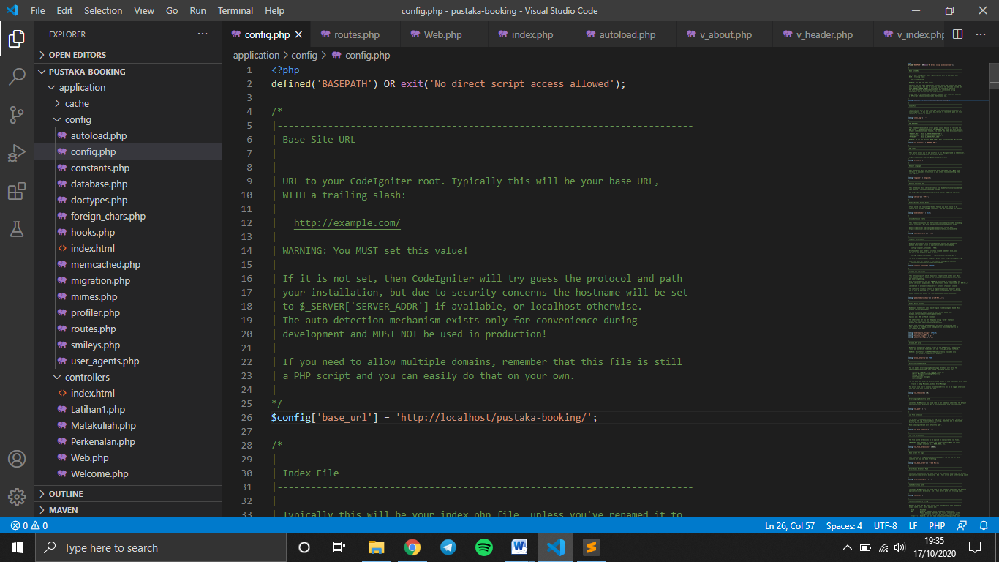

autoload.php -> application/config/

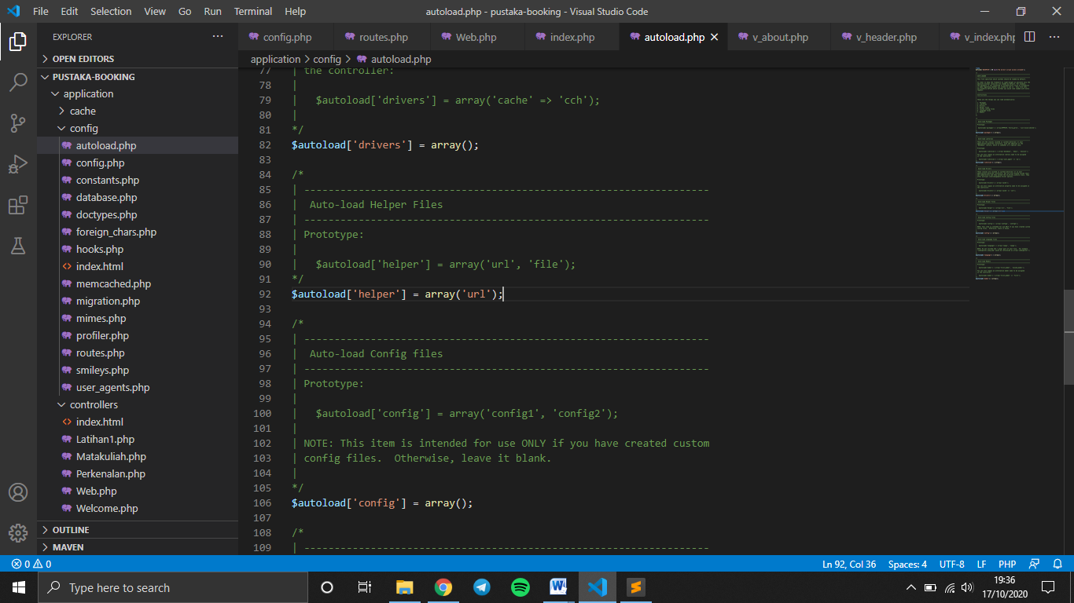

v_about.php -> application/views/

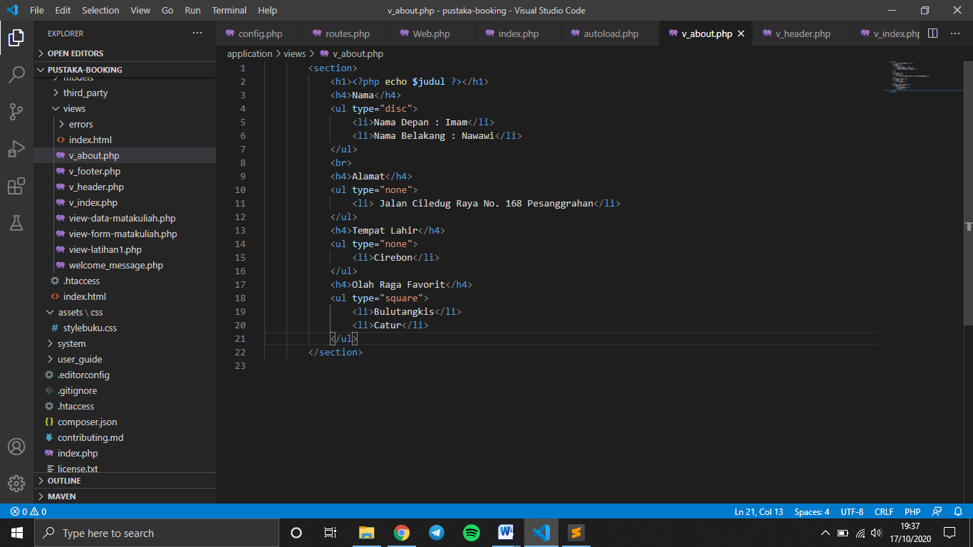

1. URL

<http://localhost/pustaka-booking/web>

<http://localhost/pustaka-booking/index.php/web/about>

1. Capture Output Program

